**Experiment Name :- Half Wave Folded Dipole**

*Student Name :- Mr.Shivam_Shirsh_Shibu*

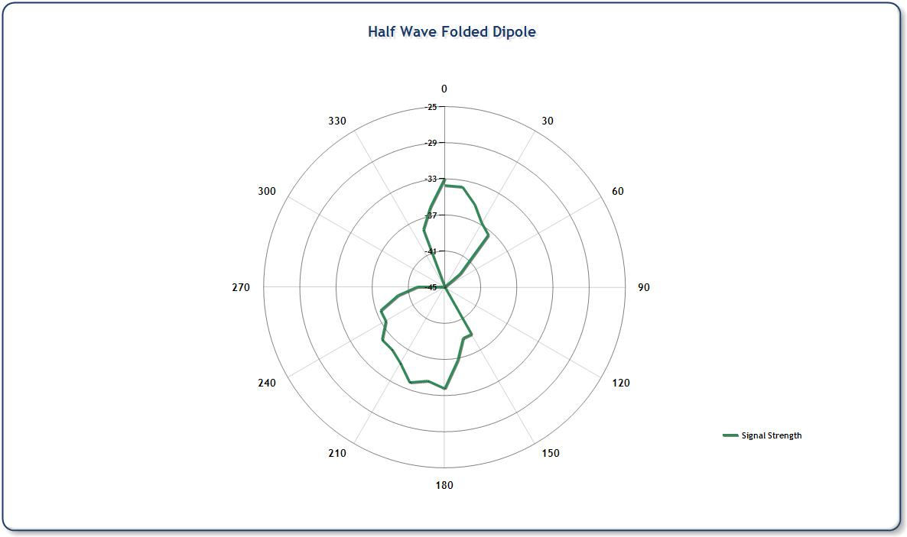

*signature of class teacher*